**Seamless Single Sign-On**

Azure Active Directory SSO Automatically signs users in when they are on their corporate devices connected to your corporate network.

Prerequisites for SSO:

* Setup AD Connect server with Pass Through Authentication or Password Hash Synchronization.
* Use Latest version of Azure AD Connect (1.1644.0 or Later.)
* Credentials of Global Administrator and On-Premises Active Directory Domain Controller.
* Enable modern Authentication on Azure AD Tenant.
* Use Latest version of M365 clients.

**Steps to Configure Seamless Single Sign-on:**

1. **On the On-Premises Azure AD Connect server open the Azure AD Connect click on configure, Select Change-User Sign in click on Next.**
2. **Now enter the Global Admin Credentials for your Tenant.**
3. **Now enable the single sign-on**

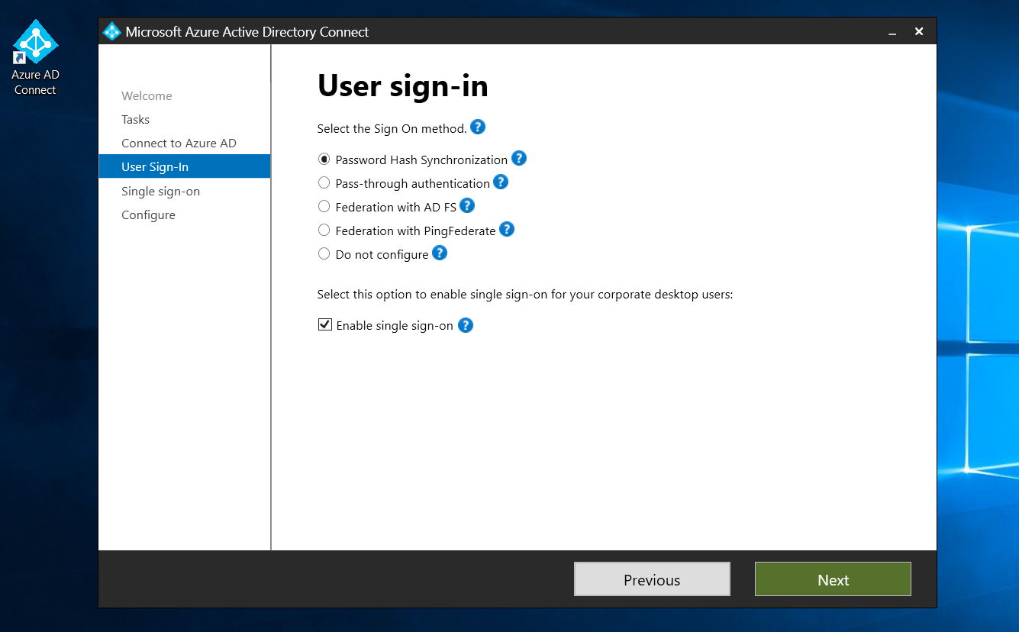

1. **Enter the credentials of the On-Premises DC for which you want to configure SSO.**

1. **Now go to Microsoft Entra ID click on Microsoft Entra connect: check whether the SSO is configured for the domain.**

**Now we have to create a Group Policy on-premises Active Directory to roll out seamless SSO to the users**

**Enable the Site to zone Assignment List and enter the URL**

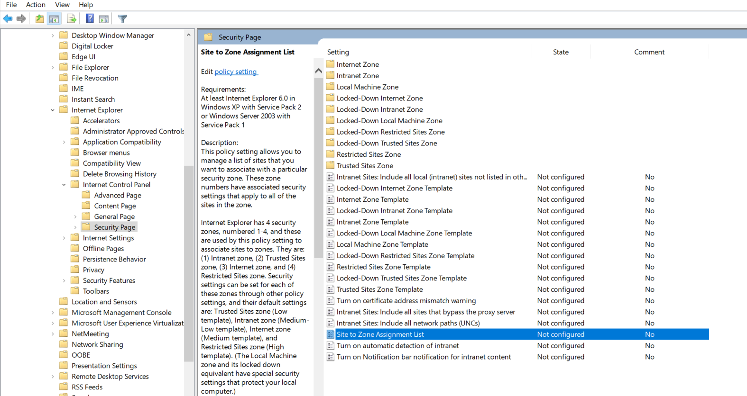

**https://autologon.microsoftazuread-sso.com value 1**

**Now under the Internet control Panel 🡪 Security Page🡪 Intranet Zone🡪 Allow updates to status bar via script.**

**Double click on this Policy click on Apply and Ok.**

**Now go to User Configuration🡪 Preferences 🡪 Windows Settings🡪 Registry now right click on registry click on new🡪Registry Item**

**Follow this article:** [**https://learn.microsoft.com/en-us/azure/active-directory/hybrid/connect/how-to-connect-sso-quick-start**](https://learn.microsoft.com/en-us/azure/active-directory/hybrid/connect/how-to-connect-sso-quick-start)

**To update the values in the registry.**

**Now go to command prompt: gpupdate /force.**